1. Environmental Chemistry
- Scope: Covers all aspects of environmental chemistry, including water chemistry and climate change impacts. ACS Publications+2Wikipedia+2Wikipedia+2
- Publisher: CSIRO Publishing Wikipedia+2Wikipedia+2PubMed+2
- Impact Factor: 4.3 (2022) Wikipedia+2NJSL Digital Collections+2MDPI+2
- Website: Environmental Chemistry Journal
2. Water
- Scope: An open-access journal covering water science and technology, including groundwater quality and contamination studies.
- Publisher: MDPI MDPI+1MDPI+1
- Impact Factor: 3.530 (2021) MDPI
- Website: Water Journal
3. Geosciences
- Scope: Focuses on geoscience research, including hydrogeochemistry and groundwater management.
- Publisher: MDPI ACS Publications+6Frontiers+6arXiv+6
- Special Issue: Previously featured a special issue on "Hydrogeochemistry and Groundwater Management" MDPI
- Website: Geosciences Journal
4. Environmental Science: Water Research & Technology
- Scope: Emphasizes research on water quality, treatment, and supply, including the effects of climate change on water resources.
- Publisher: Royal Society of Chemistry
- Impact Factor: 4.540 (2021)
- Website: Environmental Science: Water Research & Technology
5. Journal of Hydrology
- Scope: Publishes research on the science, policy, and management of water resources, including groundwater hydrology and quality.
- Publisher: Elsevier PubMed
- Impact Factor: 5.722 (2021)
- Website: Journal of Hydrology
6. Environmental Geochemistry and Health
- Scope: Focuses on the geochemical aspects of environmental health, including studies on metal contamination in water sources.
- Publisher: Springer
- Impact Factor: 3.947 (2021)
- Website: Environmental Geochemistry and Health
7. Hydrology and Earth System Sciences
- Scope: An open-access journal covering hydrology and interactions with the earth system, including climate change impacts on water resources.
- Publisher: European Geosciences Union Wikipedia+1Wikipedia+1
- Impact Factor: 5.719 (2021)
- Website: Hydrology and Earth System Sciences

Statistical Patterns and Factor Analysis of Heavy Metal Contaminants in British Columbia Groundwater: A Correlation-Based Approach

Anita Taylor, Leili Abkar, Ed McBean

Authors etc.

Abstract
A comprehensive province-wide statistical analysis of heavy metal contamination patterns in British Columbia groundwater is developed. Using data from the Provincial Groundwater Observation Well Network (1982-2022), spatial and temporal distribution patterns of arsenic, manganese, lead, and uranium across diverse aquifer systems are developed. Factor analyses identified five primary controlling factors influencing the evolution as: hydrogeochemical processes dominated by specific conductance and calcium indicators (24.4% variance), a temporal-redox component characterized by lead, iron, and manganese with inverse time relationship (13.6%), temperature influences (11.5%), and aquifer-type factors distinguishing confined, unconfined, and fractured systems (20% cumulative variance). Metal-specific analyses revealed distinct contamination mechanisms for each element, with uranium displaying strong relationships with calcium-carbonate indicators and temperature variables, manganese showing strong iron association with significant aquifer-type influence, and lead demonstrating decreasing concentrations over time. Arsenic showed minimal predictable patterns, suggesting localized, site-specific influences. Regression modeling identified complex, nonlinear metal-temperature relationships, with manganese exhibiting threshold-dependent responses to both absolute temperatures and climate-change-driven anomalies. The findings indicate that hydrogeochemical processes dominate metal distributions in confined aquifers, while temporal and climate variables significantly influence metal mobilization in unconfined systems. These results provide critical insights for groundwater quality management in British Columbia, particularly as climate change continues to alter temperature regimes and precipitation patterns. Future research should incorporate spatial autocorrelation analyses and expanded monitoring in underrepresented rural regions to address current data gaps and better distinguish between anthropogenic and geogenic contamination sources.

Key words:…..
- Journals to target: Which would be ideal?
  - *Canadian Water Resources Journal (CWRJ):
This is what I am going for – it is low impact but it has a 30 day decision making process
  - *Groundwater Monitoring & Remediation (GMR)
  - *Environmental Earth Sciences (EES) (Long shot but might as well take it)
- Still need to add references:
- Fix formatting (tables/figures)
- Appendix

Introduction
Groundwater quality monitoring in British Columbia has received limited attention until the 2016 Water Sustainability Act implementation, creating significant data gaps despite escalating climate-driven supply challenges ****. Heavy metals represent critical groundwater contaminants that pose substantial human health and ecosystem risks, yet their co-occurrence patterns, spatial distribution, and temporal trends remain poorly characterized across provincial aquifer systems***.
Previous contamination studies have typically focused on localized aquifers, surface water connections, or specific anthropogenic events. These approaches suffer from sampling biases (only 1,200 mapped aquifers), inconsistent long-term monitoring, and analytical methods inadequate for capturing complex multivariate relationships***. This study presents the first province-wide analysis of heavy metal contamination patterns in British Columbia groundwater.
This research aims to: (1) identify statistical relationships between selected metals (As, Mn, Pb, U) and hydrogeochemical parameters, (2) assess aquifer characteristics' influence on metal distribution, and (3) evaluate climate variables' impact on metal mobilization processes. The methodology used herein integrates statistical analysis of long-term monitoring data (1982-2022), factor analysis to identify underlying contamination mechanisms, and regression modeling to explain relationships between contaminants and environmental parameters.
The findings contribute improved understanding of geochemical and anthropogenic controls on metal contamination, establishing an enhanced knowledge base to support future modeling efforts and evidence-based groundwater management policy.

Overall Methodology
The methodology is detailed in depth in Taylor (2024)***

Methodology for Data Sources, Storage and Management
Water quality data from British Columbia's Provincial Groundwater Observation Well Network and Environmental Monitoring System (1982-2022) were analyzed. Sampling followed BC Hydrometric Standards and Field Sampling Manual protocols, with data management adhering to BC Data Catalogue Standards.
The dataset was transformed to associate contaminant measurements with observation wells, dates, and coordinates. Data filtering removed pesticides, complex organics, toxins, and wells lacking concentration data. Parameter selection prioritized the following constituents: Total Kjeldahl Nitrogen, total phosphorus, dissolved sulfate, alkalinity (pH 4.5), hardness, potassium, calcium, and magnesium. Selected metals (lead, manganese, uranium, cadmium) were retained for their natural occurrence and relevance to sensor research. Iron was included to assess metal co-interactions. Saltwater intrusion indicators included specific conductance, chloride, and Residue Filterable 1.0u (as a turbidity proxy).
Missing values were addressed systematically: dissolved values substituted for missing total concentrations; alkalinity pH 4.5/4.2 values filled alkalinity total gaps; hardness was calculated using calcium and magnesium concentrations when missing; remaining gaps were filled with half the detection limit; and missing pH values were replaced with means from the nearest monitoring station.

Characterization of Aquifer Types
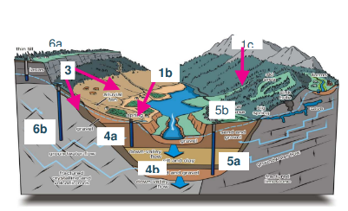
Figure 1: Diagram of B.C. Aquifer Subtype Classification in the Fraser Valley (Carmichael et al., 2008).
B.C. aquifer subtypes were consolidated into four functional groups based on hydrogeological characteristics and hydraulic connectivity: AG1 (unconfined aquifers, subtypes 1a-c, 2, 3, 4a), AG2 (confined aquifers, subtypes 4b-c), AG3 (bedrock/fractured aquifers, subtypes 5a, 6a-b), and AG4 (karst aquifers, subtype 5b) (Wei et al., 2009).
Table 1: B.C. preliminary framework for determining a hydraulic connection (Wei et al., 2016).
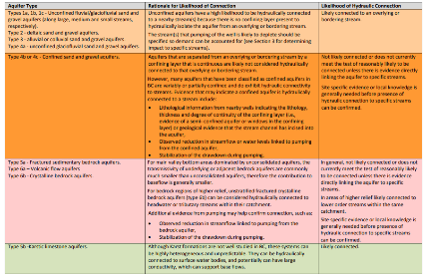

Lithological detail was limited by database constraints. Well data from B.C. Groundwater Wells and Aquifers portal was merged with aquifer classification data, with manual investigation for unmatched wells using lithological descriptions and proximity analysis. Temperature and precipitation data (1985-2022) from the Pacific Climate Impacts Consortium was incorporated using only stations with both observational and climatological records, excluding soil parameters, short-duration events, and seasonal monitoring stations. Wells were algorithmically paired with their nearest operational weather stations, eliminating stations with significant temporal gaps. The final dataset integrated BC Hydro and Environment Canada observations (with BCH data standardized for temporal resolution), calculating monthly precipitation sums and temperature means for comparison with climatological norms to enable anomaly detection, although snow measurements were omitted despite acknowledged limitations for drought assessment.

Methodology for Preliminary Exploratory Data Analysis
Initial exploration employed Power BI for rapid data assessment. Metal concentrations (As, Cd, Mn, Pb, U) were evaluated against Canadian drinking water standards and examined in relation to geochemical parameters (alkalinity, Fe, K, N, Ca, P, sulfate, hardness, pH) and saltwater intrusion indicators (chloride ≥150 mg/L, specific conductance ≥1000 µS/cm, residual non-filterable ≥700 mg/L). Distribution analyses revealed significant right skewness in most variables.
Advanced analysis incorporated climate metrics by deriving flood/drought indicators (monthly precipitation minus climatology), minimum temperature anomalies (MT), and maximum temperature anomalies (HW) to account for climate change effects. The dataset was restructured into a star schema removing extraneous identifiers.
Further processing utilized Python for computational efficiency. Aquifer subtypes were classified into three groups. Summary statistics guided analytical approaches with 10%, 50%, and 90% percentiles addressing data skewness. Outliers were managed using interquartile range thresholds rather than standard deviation methods to preserve critical high values while removing impossible measurements. Yeo-Johnson transformation normalized the multidimensional, multi-scale dataset when log and square root transformations proved inadequate.
Statistical analysis employed Pearson (linear relationships), Kendall (variable influence ranking), and Spearman (non-linear associations) correlation coefficients. Multivariate outlier detection via Mahalanobis distance with one-hot encoding identified 3% of observations as outliers, which were retained to prevent overfitting.
Visualization techniques included temporal distribution analysis, concentration patterns, parameter relationships, and regulatory threshold exceedances across aquifer groups, with particular focus on saltwater intrusion indicators and metal contamination patterns.

Factor Analysis Methodology
Factor analysis was conducted in Python using Factor Analyzer and Pingouin libraries (reference). Data preprocessing included removing climatology data, converting geographic coordinates to distances via haversine formula, implementing one-hot encoding for aquifer groups, and converting dates to numerical months-since-first-sample. Outliers were managed using IQR method with threshold replacement, except for uranium where only lower outliers were removed to preserve contamination indicators. Data weres scaled using Yeo-Johnson transformation.
Data suitability was assessed through Kaiser-Meyer-Olkin (KMO) and Bartlett's sphericity tests. Initial analysis (KMO=0.72) indicated moderate suitability, with eigenvalue analysis suggesting 7-9 factors capturing 75.5% of variance. Preliminary analysis employed Varimax rotation, generating heatmaps of factor loadings and variable communalities. Variables with loadings <|0.40| across all factors and those with high uniqueness values (K, Fe, P, N, pH, y-coordinate, precipitation) were eliminated.
Primary analysis utilized Promax rotation to allow factor correlation, with 5-6 factors identified as optimal. Residual matrix analysis verified model fit. Cronbach's alpha assessed internal consistency for positively correlated factors.
Metal-specific analysis employed oblique rotation to maximize inter-factor differentiation while maintaining interpretability. Separate models for As, Mn, Pb, and U (KMO≈0.70) identified key influencing factors for each metal, with factors determined by eigenvalues >1, excluding hardness and flood/drought indicators to avoid multicollinearity.

OLS Regression Modeling Methodology
The modeling approach employed Ordinary Least Squares (OLS) regression to identify potential predictors of groundwater contamination. Data preprocessing involved importing and cleaning data in Pandas, engineering temporal features, encoding categorical variables, converting geographic coordinates using the haversine formula (Rapp, 1991), extracting temporal information, managing outliers through interquartile range capping and median absolute deviation thresholding, and applying Yeo-Johnson power transformations to normalize continuous variables.
After correlation analysis, multiple linear regression models were developed for arsenic, manganese, lead, and uranium concentrations as dependent variables. Feature selection implemented backward elimination with 30-fold cross-validation, removing features based on their contribution to cross-validated R² and terminating when R² began decreasing (Brydon, 2021; Kong et al., 2020). The optimal feature subsets were determined by maximum cross-validated R², and performance plots were generated for each configuration. Final OLS models were fitted to these optimal subsets, with coefficients having P>0.05, t<2.0, or confidence intervals containing zero subsequently removed. Detailed results are presented in Appendix 9.9(of this paper? and Section 7, although no formal model evaluation or testing was performed.

OLS Regression Models for Groundwater Metal Contaminants
Ordinary least squares (OLS) regression models were employed as an exploratory analytical tool to identify potential predictors of groundwater contamination. This approach was selected for its ability to determine linear relationships between variables that demonstrated stronger associations than initially suggested by Pearson correlations. The models served to identify significant predictors, guide hypothesis development, and support feature selection while minimizing overfitting risk.
Four autoregressive models were developed for arsenic, manganese, lead, and uranium (detailed in Appendix 9.9)(are these in your thesis or within this paper?. The arsenic model identified nine optimal features ('Alkalinity', 'Chloride', 'Fe', 'P', 'Sulfate', 'Hardness Total', 'K', geographic position 'x', and 'Months_Since_First_Sample'), achieving a score of 0.1239. These variables explained 31% of arsenic variance (adjusted R²). The F-statistic (49.59, p<0.001) confirmed the model's statistical significance over a null model, though elevated AIC and BIC values suggest limited generalizability. Residual analysis revealed slight right skewness, non-normal distribution (Omnibus and Jarque-Bera tests, p≈0), mild positive autocorrelation (Durbin-Watson=1.578), and acceptable multicollinearity levels.
The manganese model incorporated 13 features ('Alkalinity Total 4.5', 'Fe-T', 'Total nitrogen', 'Residue Filterable 1.0u', 'Hardness Total', 'K-T', 'MIN_TEMP', 'MAX_TEMP', 'FD', 'HW', 'MT', 'Aquifer_1', and geographic position 'x'), scoring 0.2229 and explaining 42% of variance. The model demonstrated statistical significance (F=55.88, p<0.001), although high AIC/BIC values again indicate limited generalizability. All predictors achieved statistical significance (p<0.05), with 'Total nitrogen' emerging as an unexpected predictor despite its absence in factor analysis. Residuals exhibited right skewness, non-normal distribution, slight positive autocorrelation (Durbin-Watson=1.503), and acceptable multicollinearity (condition number=615).
The lead model identified nine optimal features ('Alkalinity Total 4.5', '-', 'Residue Filterable 1.0', 'Sulfate', 'pH', 'HW', 'x', 'y', and time), with a score of -9.3453 (Appendix 9.9). These predictors explained 72% of lead variance, with highly significant F-statistics suggesting strong explanatory power. The model demonstrated better fit than other metal models (less negative log-likelihood, smaller AIC/BIC values), indicating improved generalizability. However, total alkalinity and pH exceeded the p>0.05 threshold, while phosphorus, residue filterable, and sulfate showed statistically significant relationships with smaller standard errors than their confidence intervals. Geographic position ('x') and time variables exhibited suspiciously small confidence intervals that included zero despite significant p-values. Residuals showed right skewness (kurtosis=4.055), non-normal distribution (Omnibus and Jarque-Bera tests, p≈0), positive autocorrelation (Durbin-Watson=1.202), but acceptable multicollinearity.
The uranium model incorporated nine predictors ('N', 'MIN_TEMP', 'MAX_TEMP', 'FD', 'MT', 'Aquifer_1', 'Aquifer_2', 'x', 'y'), scoring -1.8067 and explaining 34% of variance (adjusted R²=0.34). The model achieved statistical significance (F=58.06, p<0.001), although high log-likelihood, AIC, and BIC values suggest limited generalizability. Nitrogen demonstrated marginal significance (t≈-2.15, p=0.032) despite its absence in factor analysis. Temperature variables (maximum, minimum, and minimum temperature difference), and aquifer groupings demonstrated statistical significance with acceptable confidence intervals. The precipitation difference variable ('FD') failed to achieve significance (p=0.095). Residuals exhibited slight right skewness (skew=0.2013), light-tailed distribution, non-normality (Omnibus and Jarque-Bera p<0.05), positive autocorrelation (Durbin-Watson=1.1171), and acceptable multicollinearity (condition number=649).
Future research should explore generalized additive models and detrended time series analysis to address the non-linear relationships suggested by these findings.

Framework for Groundwater Contamination Characterisation in British Columbia

Figure 2: Power Bi Map of observation well stations in British Columbia.
Figure 3.1 depicts observation wells across British Columbia with corresponding weather stations (Appendix 8.1).(thesis? Geographic separation between monitoring points introduces uncertainties that may obscure contamination patterns, particularly during precipitation events.
Aquifer mapping (Appendix 8.1) reveals monitoring concentrated in industrialized areas, creating critical blind spots in rural regions that may serve as unrecognized contaminant pathways. Time constraints (notsure what this means)prevented spatial autocorrelation analysis, hampering differentiation between localized influences and broader geological patterns (Griffith, 1992)Future studies should implement Queens/Morran autocorrelation methods, DBScan clustering algorithms (Hasana & Fitrianah, 2023), and spatial-temporal analysis (D. Xu et al., 2021)to identify contamination hotspots and track pollutant movement through BC's complex hydrogeology (Chouaib & Caissie, 2021; Fulton et al., 2004)
Hydrological data (Appendix 8.1) indicates concerning instances where flood thresholds were exceeded. The timing of precipitation relative to low flow periods (D. Allen & Gleeson, 2023), (if there aren’t two ‘D’s will need to remove the D2023) is particularly significant in regions where frozen ground accelerates contaminant transport to recharge zones. One-hundred-year events can overwhelm protective infrastructure, creating direct pathways for pollutants (Weiss et al., 2008) and transporting contaminants across substantial distances (Hartmann et al., 2021). More frequent 10-year events may gradually degrade water quality through cumulative impacts (Santos et al., 2011a).
BC's eight low flow hydrology zones (Coulson & Obedkoff, 1998) represent periods of vulnerability when decreased hydraulic gradients alter contamination dynamics. Reduced dilution capacity concentrates pollutants (Mohan et al., 2023) with shallow aquifers connected to intermittent streams facing particular risk (Mohan et al., 2023)
Figure 3.2 displays BC's hydrologic zones (updated in Appendix 8.1), representing areas with homogeneous characteristics for groundwater behavior assessment (B.C. Ministry of Environment and Climate Change Strategy, 2023) and indicating whether recharge is pluvial, nival, or mixed (D. M. Allen et al., 2014). Monitoring infrastructure concentrates within southern zones, creating spatial bias. The Fraser Plateau's braided channels transport mining contaminants extensively (Jones, 1990), while Thompson region's fractured basalt mobilizes uranium and arsenic. Appendix 8.1 demonstrates integration of hydrogeologic boundaries with stream networks (Schnorbus et al., 2010), highlighting the necessity of connecting surface water dynamics with groundwater contamination patterns.
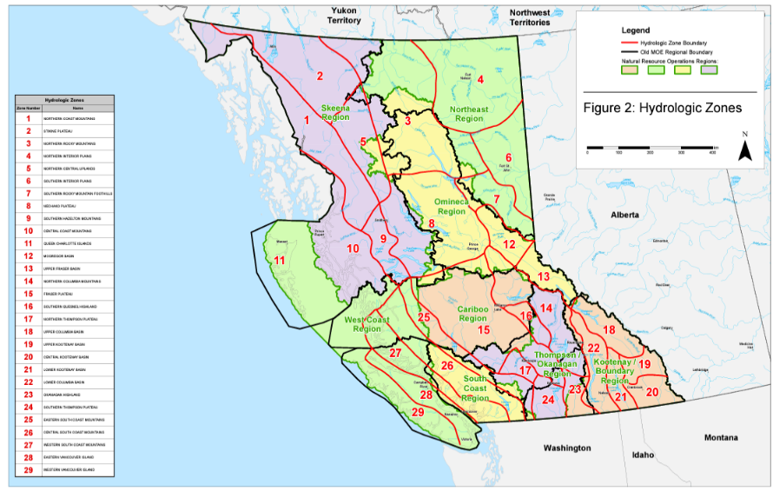
Figure 3: Map of B.C. hydrologic zones from (B.C. Ministry of Environment and Climate Change Strategy, 2023)
Geological, geologic era, and Quaternary geology maps (Appendix 8.1) reveal critical groundwater contamination pathways in British Columbia. The geology map identifies rock formations that directly influence contaminant infiltration, retention, and transport in aquifer systems.
The geologic era map documents how tectonic processes created the hydrogeological framework through which groundwater flows (Earle, 2019b). Proterozoic crustal thinning (Mossop & Shetsen, 1994), Precambrian rifting, and Mesozoic-Cenozoic subduction formed distinct terranes (Figure 3.3) that now control regional groundwater chemistry, with certain terranes introducing elevated metal concentrations into aquifers (Development, n.d.; Ootes et al., 2017). Fault systems act as preferential groundwater flow conduits, accelerating contaminant transport between otherwise isolated aquifer units.
Quaternary geology (Fulton, 1989) shaped the surficial materials through which contamination enters groundwater systems. Glacial deposits from Cordilleran ice sheet dynamics (Fulton et al., 2004) created heterogeneous aquifer materials with variable hydraulic conductivity that dictate contaminant migration rates and pathways.
Soil classification (Lavkulich, 2021; Soil Classification Working Group, 1998) directly impacts groundwater vulnerability. Brunisolic soils provide minimal protection, allowing rapid contaminant infiltration into bedrock aquifers, while acidic podzolic soils actively mobilize heavy metals into groundwater (Lavkulich, 2021). Gleysolic soils may protect deeper aquifers but facilitate lateral contaminant spreading in shallow groundwater systems (Santos et al., 2011b). The Quesnel Highland exemplifies these relationships, where uraniferous zones leach uranium directly into groundwater through redox interactions with brunisolic materials (Larry D Jones, 1990).
Parent materials (Figure 3.3) control groundwater vulnerability and contaminant behavior. Alluvium/colluvium creates highly permeable aquifers with minimal filtration capacity, enabling rapid contaminant plume development (Y. Yang et al., 2023). Organic-rich deposits generate anoxic groundwater conditions that mobilize manganese and other redox-sensitive contaminants (Ciszewski & Grygar, 2016). Morainal deposits form complex aquitard-aquifer systems with unpredictable contaminant transport patterns (Jia, 2015). Glaciofluvial outwash creates extensive, highly conductive aquifers capable of transporting contaminants over kilometers, particularly evident in Nelson region groundwater systems (Edwards et al., 2022). Weathered residual soils continuously release geogenic arsenic into underlying aquifers across central British Columbia (Lavkulich, 2021). Morainal materials create both protective barriers and preferential groundwater flow paths that complicate contaminant transport modeling (Ganoulis, 2009), while saturation zones alter redox conditions, transforming relatively insoluble contaminants into mobile groundwater pollutants (Mosley et al., 2014)

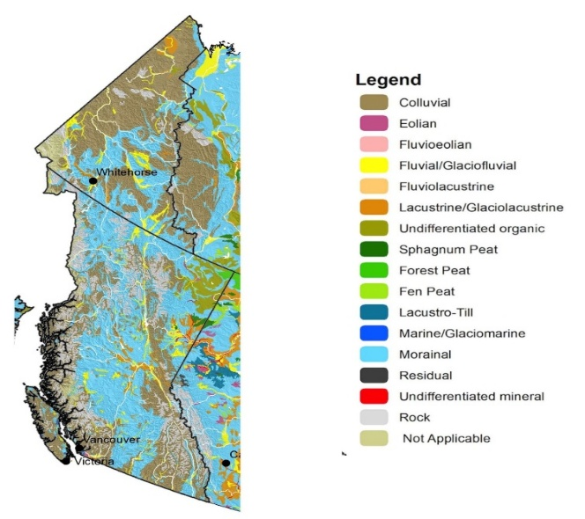
Figure 4: Left: Map of geological terranes of British Columbia (Ootes et al., 2017). Right: Soil parent materials in British Columbia (Lavkulich, 2021).

Exploratory Data Analysis
Table 2: Pearson (σ, cutoff p ≥ 0.5) and Kendall rank (τ) correlations for each element of interest (As, Mn, Pb, U) for the entire dataset and the dataset with aquifer group
 | U--T |  |  |  | Pb-T |  |  |  | Mn-T
 | Total Dataset |  | Aquifer Group 1 |  | Total Dataset |  | Aquifer Group 1 |  | Total Dataset |  | Aquifer Group 1
Correlation | σ | τ | σ | τ | σ | τ | σ | τ | σ | τ | σ | τ
Fe-T |  |  |  |  | 0.492 | 0.375 |  |  | 0.505 | 0.411 | 0.504 | 0.426
y |  |  | 0.539 | 0.284
Alkalinity Total 4.5 |  |  | 0.727 | 0.476
Hardness Total | 0.561 | 0.362 | 0.665 | 0.466
Specific  Conductance |  |  | 0.566 | 0.454
Ca-T | 0.567 | 0.398 | 0.646 | 0.466
Sulfate |  |  | 0.554 | 0.394
x |  |  | 0.571 | 0.246
Time (Months) |  |  |  |  | -0.827 | -0.473 | -0.804 | -0.405
In Aquifer group 1 (AG1), As did not have any strong correlations between any of the other contaminates.
B.C.'s alkalinity is predominantly a function of geology (Raudsepp et al., 2024). Northeastern B.C. tends to have higher alkalinity exceeding 200 mg/L due to carbonate-rich bedrock such as limestone and dolostone, while groundwater interacting with volcanic rocks in southwestern B.C. exhibits significantly lower alkalinity (Earle, 2019b). This pattern is evident for uranium in AG1, where positive spatial correlations indicate alkalinity becomes more strongly associated with uranium concentrations with increasing latitude/Longitude that concede with previously mapped uranium deposits (***). Localized natural dissolution of carbonate minerals without corresponding increases in major ions could explain the observed discrepancy between hardness and specific conductance/alkalinity in the dataset (Arciszewski & Roberts, 2022).
Elevated uranium correlates with increasing specific conductivity, hardness, calcium, alkalinity, pH, and turbidity, suggesting enhanced rock-water interactions influenced by evolving ion geochemistry (Appelo & Postma, 2004; Smedley & Kinniburgh, 2023). Uranium mobility depends on its oxidation state, with U(VI) being soluble at neutral to alkaline pH (Alam & Cheng, 2014), particularly when complexed with calcium-carbonato species (Skierszkan et al., 2020). Despite the positive correlation with sulfate observed in scatterplots, sulfate-reducing conditions typically immobilize uranium (Smedley & Kinniburgh, 2023). Spatial autocorrelation analysis may clarify this apparent contradiction.
High lead concentrations coupled with low specific conductance, turbidity, and chloride levels suggest mobilization from groundwater infrastructure rather than aquifer materials (Kampbell et al., 2003), though corrosivity indices showed no clear patterns (Nguyen et al., 2011). Localized contamination from leaded petroleum or mining waste offers an alternative explanation for elevated lead concentrations (Earle, 2019b), potentially explaining the negative temporal correlation.
Manganese and iron exhibit linked geochemistry due to their variable redox states and microbial mediation (Hamer et al., 2020). Reducing conditions favor soluble Mn²⁺ and Fe²⁺, while oxidizing environments promote formation of insoluble Mn⁴⁺/Fe³⁺ hydroxides (Z. Zhang et al., 2020). Microbial iron reduction often indirectly reduces manganese and vice versa (Gounot, 1994). Flow stratification influences these reduction processes (Appelo & Postma, 2004). While this Fe-Mn coupling was expected, future research should examine aquifer and borehole properties (Hamer et al., 2020). Both elements readily adsorb to sediments in oxygenated recharge zones (Ahmad, 2012), with sedimentary and volcanic aquifers showing elevated concentrations versus granitic and metamorphic terrains due to mineral contact time differences (Appelo & Postma, 2004)—likely explaining observations in aquifer group 1. Mn and Fe also sequester phosphorus in similar aquifer systems (Huang et al., 2023).
Table : Pearson (σ, cutoff p ≥ 0.5) and Kendall rank (τ) correlations for each element of interest (As, Mn, Pb, U) for the entire dataset and the dataset with aquifer group 2
 | U--T |  |  |  | Pb-T |  |  |  | Mn-T
 | Total Dataset |  | Aquifer Group 2 |  | Total Dataset |  | Aquifer Group 2 |  | Total Dataset |  | Aquifer Group 2
Correlation | σ | τ | σ | τ | σ | τ | σ | τ | σ | τ | σ | τ
Fe-T |  |  |  |  | 0.492 | 0.375 | 0.529 | 0.480 | 0.505 | 0.411 | 0.461 | 0.348
Hardness Total | 0.561 | 0.362 | 0.670 | 0.432
Specific Conductance |  |  | 0.695 | 0.441
Ca-T | 0.567 | 0.398 | 0.714 | 0.515
Residue Filterable 1.0u |  |  | 0.593 | 0.414
Alkalinity Total 4.5 |  |  | 0.698 | 0.484
Pb-T |  |  | -0.514 | -0.405
Sulfate |  |  | 0.684 | 0.478
U--T |  |  |  |  |  |  | -0.514 | -0.405
Time (Months) |  |  | 0.569 | 0.544 | -0.827 | -0.472 | -0.836 | -0.479

Aquifer Group 2 (AG2) comprised 330 samples from confined aquifers, with line and seasonality analyses revealing sampling errors in calcium, alkalinity, and hardness measurements . Sulfate, specific conductance, and dissolved chloride demonstrated induced seasonality (Johnson et al., 2011), while other parameters showed ambiguous patterns. Temporal trends included slight decreases in specific conductance and increases in TDS and sulfate. Arsenic exhibited no discernible patterns.
Uranium concentrations in AG2 (Section 9.3, Appendix) remained below CWDS guidelines, showing trends similar to but less pronounced than AG1. Uranium mobility is governed by thermodynamic controls, mineral dissolution, and desorption processes (Alam & Cheng, 2014), with adsorption occurring on Fe-Mn hydroxides, organic matter, clay minerals, and phosphate. Scatterplots suggest desorption and weathering mechanisms, with increasing specific conductance, hardness, and turbidity reflecting dissolution of native materials and consumption of carbonate buffering over time (Smedley & Kinniburgh, 2023). Time correlation in confined aquifers may indicate intrusion of saline waters creating more oxidizing conditions (Sahu et al., 2020). Distance lacked correlation, potentially due to protection from surface contamination.
Lead exists as soluble Pb²⁺ (Appelo & Postma, 2004) and typically coexists with uranium in rocks (L. Zhang et al., 2022), though cation competition may explain observed disparities. Lead readily sorbs to clays, calcites, and metal oxides at neutral pH (Appelo & Postma, 2004), with pH decreases in deeper aquifers and CO₂ injections potentially mobilizing lead from iron oxyhydroxides. Anthropogenic contamination from pipes or disrupted confining layers may also contribute (Jurgens et al., 2019).
Fe-Mn relationships appear partially decoupled in AG2. Scatterplots showing high Mn/Fe levels with low turbidity/phosphorus and high hardness suggest crystalline iron and manganese oxide/hydroxide minerals under reducing conditions (Appelo & Postma, 2004). Elevated potassium with lower turbidity indicates slower weathering processes and longer residence times (Appelo & Postma, 2004; Meyers et al., 2021), while hardness primarily reflects calcium/magnesium from carbonate weathering rather than manganese/iron oxides (Appelo & Postma, 2004).
Table : Pearson (σ, cutoff p ≥ 0.5) and Kendall rank (τ) correlations for each element of interest (As, Mn, Pb, U) for the entire dataset and the dataset with aquifer group 3
 | U--T |  |  |  | Pb-T |  |  |  | Mn-T
 | Total Dataset |  | Aquifer Group 3 |  | Total Dataset |  | Aquifer Group 3 |  | Total Dataset |  | Aquifer Group 3
Correlation | σ | τ | σ | τ | σ | τ | σ | τ | σ | τ | σ | τ
Fe-T |  |  |  |  | 0.492 | 0.375 | 0.616 | 0.516 | 0.505 | 0.411 | 0.563 | 0.415
Hardness Total | 0.561 | 0.362
Pb-T |  |  | -0.574 | -0.470
Ca-T | 0.567 | 0.398
U--T |  |  |  |  |  |  | -0.574 | -0.470
Time (Months) |  |  |  |  | -0.827 | -0.472 | -0.843 | -0.604

Aquifer Group 3 (AG3) comprised 300 samples from fractured bedrock formations, with
arsenic showing no significant correlations. Fractured bedrock systems feature preferential flow conduits with primary transport occurring through fissures while solute exchange happens via diffusion with matrix water (Appelo & Postma, 2004). These systems typically produce clearer groundwater with lower ion concentrations due to limited rock-water interactions. Lithification in deep sedimentary fracture zones further reduces porosity and water-rock contact (Ofterdinger et al., 2019), while phreatic zones remain largely isolated from surface processes (Wossenyeleh et al., 2020).
Manganese exceeding CDWS guidelines (Section 8.3, Appendix) correlated with elevated alkalinity, calcium, iron, potassium, and hardness, following patterns similar to Aquifer Group 1, but with lower specific conductance and turbidity. Mn-Fe associations were weak, as in AG1. Formation upwelling following circulation may transport these ions to the surface through fracture networks (Ofterdinger et al., 2019), explaining the similarity to unconfined aquifer patterns.
Lead behavior in AG3 resembled that of AG2/confined aquifers, suggesting comparable geochemistry and flow regimes. Uranium patterns differed markedly, primarily due to well locations predominantly in the coastal belt where uranium deposits are absent (****). The uranium present is likely anthropogenic, explaining its correlation exclusively with lead.

Primary Factor Analysis
Exploratory factor analysis identifies predictor variables and underlying processes beyond simple correlation methods by examining multivariate structures simultaneously (Briz-Kishore & Murali, 1992). For our non-normal dataset, factor analysis revealed multicollinearity and common underlying variables that pairwise correlations miss, providing advantages over Kendall and Pearson correlations which only measure bivariate relationships (Mulaik, 2009; Hair et al., 2019).
The dataset achieved a KMO value of 0.7526, indicating adequate sampling adequacy for exploratory analysis though not as stringent for modeling (Hair et al., 2019). Variables without significant factor loadings (<0.4) were eliminated, including precipitation and arsenic (Mulaik, 2009). Variables with moderate loadings (0.4-0.7) but high uniqueness were also removed (Hair et al., 2019), including distance factors. The refined dataset (16 variables, KMO=0.7481) yielded five factors using promax rotation, collectively explaining 70% of variance

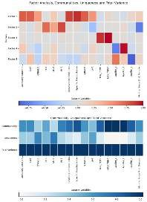
Figure 5: Final promax factor analyis
This figure will have to be larger as not readable

The first factor (F1) represented 24.4% of proportional variance, characterized by high loadings from specific conductance [0.9167], residue filterable [0.8647], Ca [0.7572], alkalinity [0.7572], and sulfate [0.7530], with weaker contributions from uranium and chloride (Section 8.7, Appendix).
This signature suggests saltwater intrusion or water-rock geochemistry processes, possibly from historical coastlines at different geological ages (Bethke & Marshak, 1990; Chen et al., 2018). Such hydrochemical factors typically dominate groundwater factor analyses (Chen et al., 2018; Farnham et al., 2003; Kuppusamy & Giridhar, 2006). The high specific conductance could indicate coastal sedimentary rocks, past seawater intrusion during sea level rises, buried residual salts, or saline fossil groundwater (Appelo & Postma, 2004). Similar patterns in Northern British Columbia have been attributed to past seawater intrusion and upward migration of older saline basal brines (VanGulck, 2016).
The parameters suggest ion exchange, saline intrusion or diffusion processes, but further evaluation requires additional geological and hydrological data (Appelo & Postma, 2004). Future research should include silica measurements to differentiate mineral weathering from carbonate dissolution, correlate scores with pumping rates and coastline proximity, and overlay results with aquifer properties (Kuppusamy & Giridhar, 2006). More accurate characterization would require separating hydraulic and geoclimatic zones and incorporating geological factors like carbonate and evaporate deposits (Belkhiri & Narany, 2015). F1 may be influenced by evaporate deposits, carbonate rock, superficial geology, and structural features like faults that channel deeper saline fluids (Dalton & Upchurch, 1978).
Factor 2 (F2) explained 13.63% of proportional variance, characterized by strong loadings from Pb [0.8249] and Fe [0.7101], with a pronounced negative correlation with time (Months_Since_First_Sample) [-0.7700] and weaker association with Mn.
This temporal component suggests evolving redox conditions affecting metal concentrations over time. Fe, Pb, and Mn are redox-sensitive elements whose solubility varies with changing biogeochemical conditions (Appelo & Postma, 2004). While groundwater chemistry naturally evolves over time, the observed changes within a 40-year timeframe may reflect climate factors, pumping patterns, or pollution rather than endemic geochemical evolution. Similar temporal shifts in manganese concentrations have been documented in large-scale U.S. groundwater studies (Ayotte et al., 2015).
Groundwater residence time likely influences these patterns—shorter residence times may indicate increased interaction with near-surface Mn-bearing formations (Poeter et al., 2020). Alternatively, anthropogenic sources cannot be ruled out, as Pb and Fe are common contaminants from well fixtures and mining activities (Witkowski et al., 2020), while Mn concentrations often correlate with well depth in shallow aquifers (Hamer et al., 2020).
Future research should incorporate spatial autocorrelations, additional redox indicators (nitrite, sulfide), and geological correlations to better characterize these processes (Appelo & Postma, 2004). Bootstrap resampling could establish confidence intervals to test trend stability (Biglari et al., 2018).
Factor 3 (F3) accounts for 11.5% of proportional variance, dominated by minimum and maximum average monthly temperatures. Maximum temperature loadings exceeded 1.0, indicating high correlation with minimum temperature and suggesting a climate influence mechanism.
These substantial temperature loadings cannot be definitively interpreted without additional research (Riedel, 2019). Groundwater temperature responses to climate change vary considerably, with studies reporting increases of 0.1-0.4°C per decade, modest effects limited to shallow aquifers, or negligible impacts at depth (Benz et al., 2017; R. Li, 2016; Neidhardt & Shao, 2023). Temperature investigations have focused primarily on geothermal and gas systems (Hemmerle & Bayer, 2020), with northern regions receiving attention due to permafrost influences on groundwater dynamics (Gruber & Haeberli, 2007; JR Williams, 1970).
Given the Yeo-Johnson scaling applied, these loadings may represent interannual variations driven by seasonal surface temperature fluctuations rather than absolute values (Noetzli & Gruber, 2009). The tight coupling of minimum and maximum temperatures suggests a common driver, potentially climate change. Notably, minimum (nighttime) temperatures typically rise faster than maximum temperatures under changing climate conditions, especially in northern latitudes (Karl et al., 1993). This differential warming creates temperature gradients that may influence redox reactions seasonally (Noetzli & Gruber, 2009; Sahu et al., 2020). Future research should incorporate well depth measurements and analyze differences between expected and actual temperature extremes (Karl et al., 1993).
Factors 4 and 5 together account for approximately 20% of proportional variance and represent aquifer groupings based on hydraulic connectivity and geological characteristics.
Factor 4 differentiates between Aquifer Group 1 (negative loading) and Aquifer Group 2 (positive loading). Aquifer Group 1 comprises unconfined sand and gravel aquifers with surface water connectivity (Wei et al., 2016), characterized by oxygenated modern recharge and dilution effects (Orecchia et al., 2022). This hydraulic connectivity pattern has been observed in previous groundwater studies (Ballukraya & Ravi, 1999; Briz-Kishore & Murali, 1992). Conversely, Aquifer Group 2 includes confined aquifers, some with glacial marine influence in coastal regions (Wei et al., 2016), exhibiting limited surface interaction and distinctive older groundwater chemistry (Skierszkan et al., 2021). Confined aquifers typically occur at greater depths (Cabrera et al., 2017), resulting in extended residence times, increased hydrological age, and more reducing conditions (Bakari et al., 2012). This geochemical distinction between shallow unconfined and deeper confined systems aligns with previous factor analyses (Chung et al., 2020).
Factor 5 contrasts Aquifer Group 3 (strong negative loading), representing fractured crystalline bedrock aquifers, with Aquifer Group 1 (positive loading). This factor likely captures either: (1) the geochemical contrast between shallow alluvial and deeper fractured bedrock aquifers, or (2) differences in groundwater flow mechanisms (Appelo & Postma, 2004). In Aquifer Group 1, moderate surface area interactions characterize flow through sand and gravel with relatively straightforward vadose zone percolation (Wossenyeleh et al., 2020). By contrast, fractured bedrock offers preferential flow conduits with rapid throughput and limited matrix interaction (Appelo & Postma, 2004), affecting contaminant transport and water-rock equilibration.
Analysis limitations included insufficient sampling for comprehensive evaluation of metals with either saltwater intrusion variables or climate parameters (KMO < 0.7) (Mulaik, 2009).

Metal-Specific Factor Analysis:
Oblimin factor analyses excluding other metals of interest were conducted to isolate influences on arsenic, manganese, uranium and lead.

Arsenic-Specific Factors
The arsenic-focused analysis yielded six factors explaining 57% cumulative variance, sufficient for generalization but requiring further validation (Mulaik, 2009). Notably, arsenic did not load strongly on any factor.
F1As (20% variance) represented geochemical variables including Specific Conductance [0.9453], Residue Filterable [0.8944], Alkalinity [0.7637], Sulfate [0.7223], and Ca-T [0.7038], with weak influences from chloride and potassium. This resembles the main analysis's F1 but lacks uranium and includes potassium, which may indicate influences beyond dissolved solids (Fulton et al., 2004). Uranium-arsenic co-occurrence is documented (Katsoyiannis et al., 2007; Skierszkan et al., 2020); their separation here suggests spatially localized arsenic contamination warranting spatial autocorrelation analysis.
F2As-F4As corresponded to temperature and aquifer groupings (equivalent to main factors F3-F5) with altered proportional variances. Temperature effects on arsenic mobilization are typically observed in geothermal settings with substantial temperature changes (Bonte et al., 2013; Xing et al., 2023). Fracture flow factors showed greater variance than confinement factors, contradicting expectations that anthropogenic arsenic would predominantly affect shallow unconfined aquifers (Khan et al., 2023). This may reflect spatial correlation between mining activities and fractured bedrock geology (Earle, 2019b).
F5As showed strong iron association [0.7581] with inverse temporal relationship, similar to F2 in the main analysis but without manganese and lead, potentially indicating weathering processes (Appelo & Postma, 2004). Iron minerals commonly host arsenic (Fakhreddine et al., 2021).

Manganese-Specific Factors
The manganese analysis produced six factors explaining 57.8% variance (Mulaik, 2009). F1Mn through F4Mn paralleled the arsenic analysis but with important distinctions.
F1Mn showed enhanced chloride importance and reduced alkalinity influence, contrary to manganese's established association with mineral weathering (Appelo & Postma, 2004). Aquifer-related factors (F3Mn, F4Mn) aligned with main factors F3-F4, with confined aquifers showing greater influence than in the arsenic analysis, suggesting manganese accumulation depends on longer residence times in confined systems that maximize water-rock interactions (Appelo & Postma, 2004).
F5Mn revealed a strong iron relationship [0.9201] with inverse temporal correlation, while F6Mn showed weak inverse chloride relationship alongside pH and latitude influence, suggesting localized anthropogenic effects consistent with industrial activities along British Columbia's populated west coast (Bradl, 2005; Earle, 2019b).
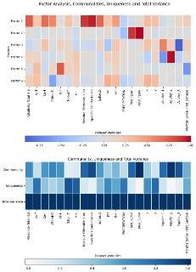
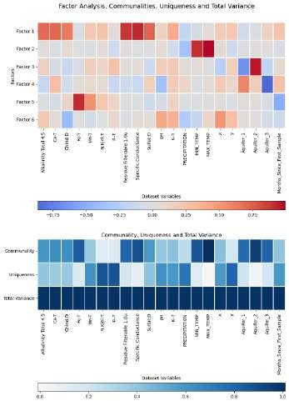
A)
B)
Figure 6: A) Factor analysis with oblimin rotation isolating arsenic as the sole metal of interest. Community, uniqueness, and total variance proportions are displayed.
B) Factor analysis with oblimin rotation isolating manganese as the sole metal of interest. Community, uniqueness, and total variance proportions are displayed

Lead Factor Analysis
The lead-focused factor analysis yielded six factors explaining 61% cumulative variance, sufficient for identifying structural patterns (Mulaik, 2009). F1Pb, F3Pb, F4Pb, and F5Pb paralleled factors in the manganese analysis.
F1Pb represented hydrogeochemical variables with strong loadings for specific conductance, residue filterable, alkalinity, and sulfate, with weaker influences from K, chloride, and Ca. The enhanced alkalinity loading relative to Ca may reflect bicarbonate ion buffering effects (Arciszewski & Roberts, 2022).
F2Pb (10% variance) showed strong lead loading [0.9200], inverse temporal correlation, and weak iron association, resembling F2 in the main analysis. This indicates geochemical controls on lead speciation and transport. The Fe-Pb association with inverse temporal relationship suggests potential anthropogenic sources (Jurgens et al., 2019), consistent with previous groundwater factor analyses (Love et al., 2004).
F3Pb-F5Pb mirrored the manganese analysis patterns emphasizing groundwater age and confinement. F6Pb exhibited weak inverse chloride correlation and weak longitude association, similar to F6Mn but without pH influence, possibly because sampled pH values (~7) were outside ranges conducive to lead mobilization (Appelo & Postma, 2004).

Uranium Factor Analysis
The uranium-focused analysis produced six factors explaining 57.8% cumulative variance (Mulaik, 2009). F1U-F4U resembled corresponding manganese factors, suggesting similar controlling mechanisms.
F1U (19% variance) represented hydrogeochemical parameters with stronger chloride than sulfate influence and greater calcium than potassium loading compared to F1Mn. This likely reflects uranium-bearing mineral geochemistry (Larry D. Jones, 1990) and previously documented uranium-chloride correlations in groundwater (Selvi et al., 2016). Calcium association likely derives from uranyl-calcium-carbonate complexes that dominate uranium speciation (Skierszkan et al., 2021; Stewart et al., 2010). Uranium showed heightened sensitivity to saltwater intrusion indicators, contrasting with prior studies (Smedley & Kinniburgh, 2023).
F5U showed weak inverse chloride relationship with weak uranium and longitude associations, suggesting anthropogenic contamination (Bradl, 2005) with geographic dependence centered in industrialized British Columbia regions, potentially indicating anthropogenic uranium sources exceed geogenic sources.
F6U exhibited strong temporal correlation [0.7409], weak uranium association, and inverse iron relationship, likely representing geogenic weathering and redox processes (Appelo & Postma, 2004; Skierszkan et al., 2021). Unlike comparable factors in other analyses, F6U showed moderate negative iron loading with strong positive temporal loading. This pattern aligns with permafrost uranium mobilization mechanisms involving sorption-desorption and calcium carbonate weathering (Alam & Cheng, 2014; Skierszkan et al., 2021), where uranyl-calcium-carbonate complexes resist reduction even below Fe(III) reduction potential. Extended residence time increases desorption reactions (Appelo & Postma, 2004), while iron can reduce and precipitate uranium (Smedley & Kinniburgh, 2023).

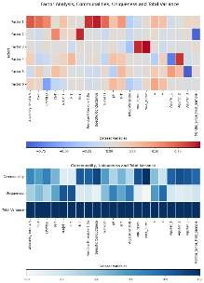
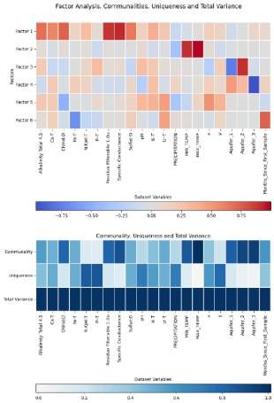
A)
B)
Figure 7: A) Factor analysis with oblimin rotation on a dataset isolating lead as the sole metal of interest, with community, uniqueness, and total variance proportions displayed.
B) Factor analysis with oblimin rotation on a dataset isolating uranium as the sole metal of interest, with community, uniqueness, and total variance proportions displayed.

Ordinary Least Squares Regression
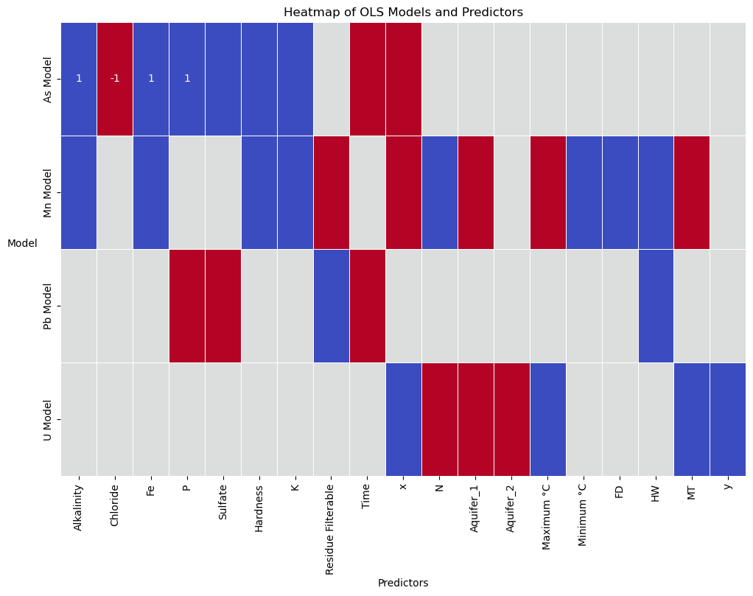
Figure 8: Statistically significant predictors from OLS regression models in B.C. groundwater. Blue represents a positive coefficient, Red represents a negative. X and Y are the Cartesian equivalents for longitude and latitude. MT and HW is how much the minimum and maximum temperature was above the simulated temperature for that time. FD is the difference between the actual and simulated precipitation.
Regression analysis identified alkalinity, chloride, iron, phosphorus, sulfate, hardness, and potassium as primary influences on arsenic concentrations, with minor temporal and aquifer confinement effects, while hydraulic connectivity and bedrock showed negligible influence (Figure 1) —suggesting concurrent natural and anthropogenic sources. Alkalinity emerged as a significant predictor, consistent with established redox chemistry affecting arsenic adsorption-desorption processes, likely superseding pH due to pH's non-monotonic threshold relationship with arsenic mobilization. Iron's influence aligns with Fe(III) absorption mechanisms, while phosphate indicates soil/anthropogenic inputs that either facilitate or compete with arsenic sorption depending on P:Fe ratios. Potassium's presence suggests anthropogenic inputs or weathering processes, with geospatial analysis indicating wells in southwestern British Columbia. The negative chloride correlation corresponds with trivalent arsenic complex formation that can immobilize and precipitate arsenic at higher Cl:As ratios, contradicting exploratory findings of elevated arsenic in saltwater intrusion zones and further supporting anthropogenic contributions.
Regression analysis of manganese revealed complex temperature-dependent relationships with apparent contradictions that likely reflect non-linear biogeochemical processes rather than model inconsistencies. Minimum temperature exhibited positive correlation with manganese, while MT (the difference between actual and simulated minimum temperature) showed negative association. Conversely, maximum temperature demonstrated negative correlation, yet HW (the difference between actual and simulated maximum temperature) displayed strong positive association. These relationships suggest threshold-dependent responses where absolute temperatures and their climate-change-driven deviations influence manganese through distinct mechanisms.
Areas with reduced temperature variability (negative MT) maintain elevated manganese levels through mechanisms beyond simple thermodynamics, while positive HW values identify regions with sustained temperatures conducive to enhanced manganese solubility through prolonged reaction times. Maximum temperatures likely reflect conditions where manganese precipitation occurs after exceeding solubility thresholds, while minimum temperatures influence mobilization through baseline kinetic controls.
Geochemical parameters (iron, alkalinity, hardness) represent bedrock influences on manganese mobility, with iron demonstrating particularly strong association due to co-occurrence and similar redox behavior. Nitrogen emerged as a significant factor, potentially functioning as an anthropogenic indicator or influencing manganese through microbial activity rather than direct control. Hydrological parameters showed significant correlations: the flood/drought indicator (FD) positively associated with manganese mobilization during elevated baseflow, while hydraulic connectivity showed negative correlation, suggesting reduced water-rock interaction time in transmissive aquifers. Filterable residue demonstrated negative association with manganese, potentially indicating aquifer media depletion through continued rock-water exchange.
Future research should employ seasonally-adjusted time series analysis to isolate climate change effects from seasonal cycling.
The lead regression model revealed that alkalinity, pH, and spatial coordinates lacked statistical significance, challenging the use of alkalinity as a geochemical indicator. Negative coefficients for phosphate and sulfate suggest potential precipitation reactions forming insoluble lead compounds or microbially-mediated sulfate/phosphate reduction processes that stabilize lead minerals. Conversely, residual non-filterable material showed a positive association with lead concentrations, aligning with factor analysis results. This correlation may reflect sediment composition in regions with salt/mineral deposits, pH-influencing minerals susceptible to rock-water interactions, buffering from carbonate/bicarbonate ions, or increased cation exchange processes on mineral surfaces facilitating lead desorption into groundwater.
The negative temporal coefficient suggests declining lead concentrations over the past 25 years, potentially due to strengthened pollution regulations and improved well maintenance. Maximum ambient monthly temperature showed a slight positive coefficient, indicating that higher daytime temperatures may accelerate weathering and lead mobilization compared to minimum temperatures. Lead demonstrated strong seasonality, suggesting its geochemical behavior remains relatively unaffected by climate change thus far and indicating potentially higher thermal tolerance for lead adsorption processes compared to manganese.
Uranium concentrations in British Columbia groundwater were predicted by nine variables, with all except FD showing statistical significance. Nitrogen exhibited a negative coefficient, potentially due to uranyl-nitrate complexation (UO₂(NO₃)₂), competition from denitrifying microorganisms utilizing nitrate as electron acceptors instead of oxygen, or altered redox conditions unfavorable for uranium solubility.
Both aquifer groups showed negative coefficients. For Aquifer Group 1, this may reflect greater oxic conditions in shallow aquifers promoting uranium immobilization, enhanced microbial reduction pathways, higher permeability facilitating uranium transport, or insufficient geochemical buffering of reducing conditions. Aquifer Group 2 (confined aquifers) may isolate groundwater from uranium-bearing recharge events and anthropogenic contamination. Additional explanations include spatial lithological variations, competition with redox-active solutes due to longer residence times, glacial compaction effects on pore water mobility, and reduced hydraulic heterogeneity.
Geographic coordinates (X, Y) demonstrated negative coefficients, suggesting either anthropogenic influences from industrial activity in southwestern regions or geological variations in bedrock composition. Spatial autocorrelation analysis could help distinguish between anthropogenic and natural determinants.
Temperature variables revealed opposing effects: minimum temperature showed a negative coefficient while maximum temperature and MT displayed positive coefficients. This pattern suggests uranium solubility increases with warming baseline temperatures, potentially indicating greater relevance to arctic water systems undergoing climate change.

Conclusion
This study presents the first comprehensive, province-wide statistical analysis of heavy metal contamination patterns in British Columbia groundwater. Factor analysis revealed five primary influencing factors: (1) a hydrogeochemical factor dominated by specific conductance, calcium, and alkalinity indicators (24.4% variance); (2) a temporal-redox factor characterized by lead, iron, and manganese with inverse time relationship (13.6% variance); (3) a climate influence factor highlighting temperature effects (11.5% variance); and (4-5) aquifer-type factors distinguishing confined, unconfined, and fractured systems (20% cumulative variance).
Initial exploratory analysis revealed distinct contamination patterns across aquifer groups. In unconfined aquifers (AG1), uranium demonstrated strong positive correlations with specific conductance, hardness, calcium, and alkalinity, reflecting enhanced rock-water interactions and calcium-carbonate complexation processes. Lead showed minimal geochemical associations but significant negative temporal trends, suggesting anthropogenic sources rather than natural weathering. Manganese exhibited moderate correlation with iron both bedrock and unconfined aquifers reflecting their linked redox behavior, though this relationship varied by hydrogeological setting. Confined aquifers (AG2) displayed more uranium-turbidity and uranium-lead relationships and had temporal trends in lead concentrations, while fractured bedrock systems (AG3) showed markedly different uranium behavior compared to other aquifer types.
Metal-specific analyses demonstrated distinct controlling mechanisms for each contaminant. Arsenic showed minimal predictable patterns and no significant factor loadings, suggesting localized, site-specific influences. Manganese exhibited strong iron association with inverse temporal correlation and sensitivity to aquifer confinement. Lead demonstrated decreasing concentrations over time with iron association and hydrogeochemical influences. Uranium displayed strong relationship with calcium-carbonate indicators and significant sensitivity to geographic position, aquifer type, and temperature variables.
Regression modeling identified complex, often nonlinear relationships that simple correlation analysis failed to detect. Temperature variables produced particularly noteworthy effects, with manganese showing threshold-dependent responses to both absolute temperatures and climate-change-driven anomalies. Geographic patterns suggest both anthropogenic and geogenic sources contribute to observed contamination, with distinct mechanisms operating across different aquifer types.
This research provides critical insights for groundwater management in British Columbia, identifying priority contaminants and high-risk aquifer configurations. Future work should incorporate spatial autocorrelation analysis, additional redox indicators, and expanded monitoring in rural regions to address existing data gaps. As climate change continues to alter groundwater dynamics, temperature-dependent mobilization of redox-sensitive contaminants warrants particular attention, especially in northern regions experiencing rapid warming.

Attachments

